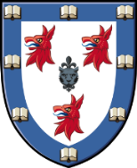
Dinner counter early closing for June
The evening dinner counter will be closing at 6.30pm on the following dates in June:
Tuesday 21st June
Wednesday 22nd June
Thursday 23rd June
Friday 24th June

We apologise for any inconvenience

