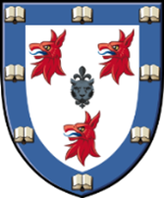

Formal Hall Menu Tuesday 21st June

Hot smoked salmon with a carrot, fennel and courgette salad, toasted walnuts and chive oil
Roasted butternut squash soup with chive oil

Pressed pork belly with burnt apple and cider puree, tender stem broccoli and caramelized red onion mash potato
Parsnip tart tatin with burnt apple and cider puree, tender stem broccoli and caramelized red onion mash potato

Rolo cheesecake with a pretzel crumb, Chantilly cream and caramel sauce

